**What relevant products and services do banks (in general)/Lloyds Banking Group (specifically) offer to their customers?**

**Overview of banking products and services (In General)**

At its most basic level, a bank is a place to safely store your money. But beyond the basics, banks often offer a wide range of products and services designed to make it easier for you to manage your money.

The primary role of banks is to take deposits and extend loans. However, banks can offer a wide range of products and services, including:

- Deposit accounts (checking accounts, savings accounts, CDs, money market accounts)

- Loans, including mortgages, auto loans, and personal loans

- Credit cards

- Check cashing services

- Wealth management services

- Insurance

- Commercial banking

[什么是银行，它是如何运作的？– 福布斯顾问 (forbes.com)](https://www.forbes.com/advisor/banking/how-do-banks-work/#:~:text=But%20banks%20can%20offer%20a%20wide%20range%20of,Wealth%20management%20services%206%20Insurance%207%20Business%20banking)

In more detail, the bank's products and services can usually be categorized into the following major groups:

**1. Personal banking services:**

- Savings accounts (including time deposit accounts and savings accounts)

- Checking accounts

- Personal loans (including mortgages, auto loans, and personal unsecured loans)

- Credit and debit cards

- Online and mobile banking services

- Investment products such as time certificates of deposit, stock and bond investment accounts

- Retirement savings accounts (e.g., pension plans)

- Insurance products, including life, health and property insurance

**2. business banking services:**

- Business accounts and checking accounts

- Business loans and credit facilities

- Trade finance

- Asset management

- Payments and cash management services

- Risk management and advisory services

**3. Investment banking services:**

- Corporate finance and advisory (including mergers and acquisitions, asset sales and restructuring)

- Capital market services (equity and bond issuance)

- Transaction services and market making

- Wealth management and private banking services

**Lloyds Banking Group’s products and services (Specifically)**

In response to Lloyds Bank's (Lloyds Bank) products and services, it covers many of the areas listed above, specifically including but not limited to:

**- Personal Banking Services:** Lloyds offers savings accounts, checking accounts, personal loans, mortgages, credit cards, insurance products (e.g., home, auto and life insurance), investment products and retirement solutions.

**- Business banking services:** business accounts, loans and credit facilities, trade finance, payments services and specialist industry advice for small and medium-sized enterprises (SMEs).

**- Corporate and Institutional Banking Services:** provides integrated financial solutions for large corporate and institutional clients, including capital management, risk management services and corporate finance advice.

**- Online and mobile banking services:** Lloyds Bank offers personal and corporate customers convenient online and mobile banking services through its website and mobile apps, enabling customers to manage accounts, transfer funds, pay bills and more.

Lloyds Bank has a wide range of products and services designed to meet the diverse financial needs of personal and business customers. Specific product and service details can be found on Lloyds Bank's official website, including the latest financial product information and service updates. [我们的工作 - Lloyds Banking Group plc](https://www.lloydsbankinggroup.com/who-we-are/what-we-do.html)

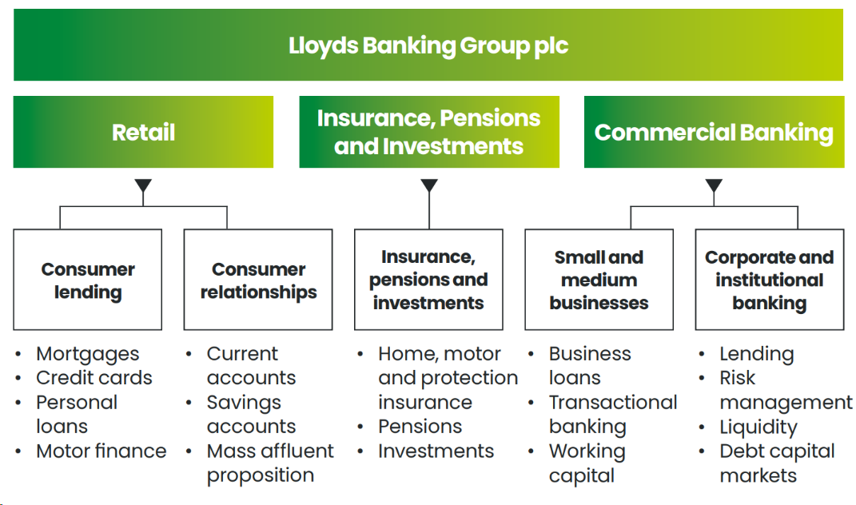

As shown, Lloyds TSB operates through three core divisions: retail, commercial banking, insurance, pensions and investments.

**Retail**

Retail offers a wide range of financial services products to individual customers, including current accounts, savings, mortgages, credit cards, unsecured loans, car finance and leasing solutions.

**Commercial Banking**

Commercial Banking serves small and medium-sized enterprises (SMEs) as well as corporate and institutional customers. The division offers lending, transaction banking, working capital management, debt financing and risk management services.

**Insurance, Pensions and Investments**

The division helps customers meet their long-term protection, retirement and investment needs through insurance, pensions, investments and wealth management.

**Conduct exploratory data analysis of the dataset in Python:**

* Aim to have an understanding of the underlying simulation used to produce the data.

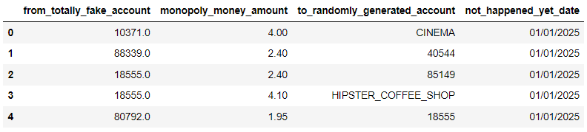

The dataset generates data on bank transactions using simulation techniques. The dataset contains 10148280 rows of data.

'from_totally_fake_account': This column contains a string of numbers representing the account that initiated the transaction.

'monopoly_money_amount': The value of the virtual amount for each transaction.

'to_randomly_generated_account': This column contains a number or text representing the account that received the transaction.

'not_happened_yet_date': The date when the transaction will occur in 2025 (future).

The dataset simulates 8,142 different customers and 14,300 different payees and contains no missing values, indicating that it is neat.

* Consider measures such as average spend per company and/or per customer (e.g. the average spend of any customer or 'Customer A' specifically at a specific Cafe).

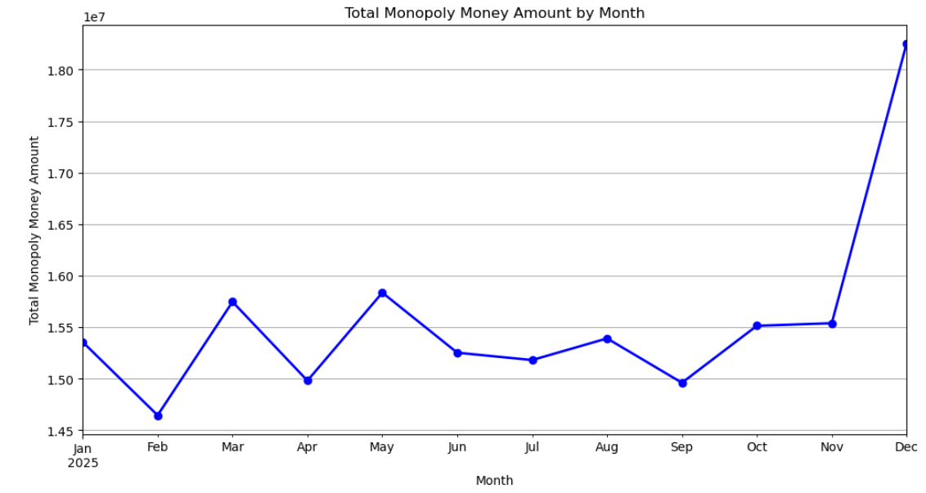

Calculating and visualizing the amount of transactions for each month reveals that the amount fluctuates within a range for the first 11 months, but there is a sudden and significant increase in December.

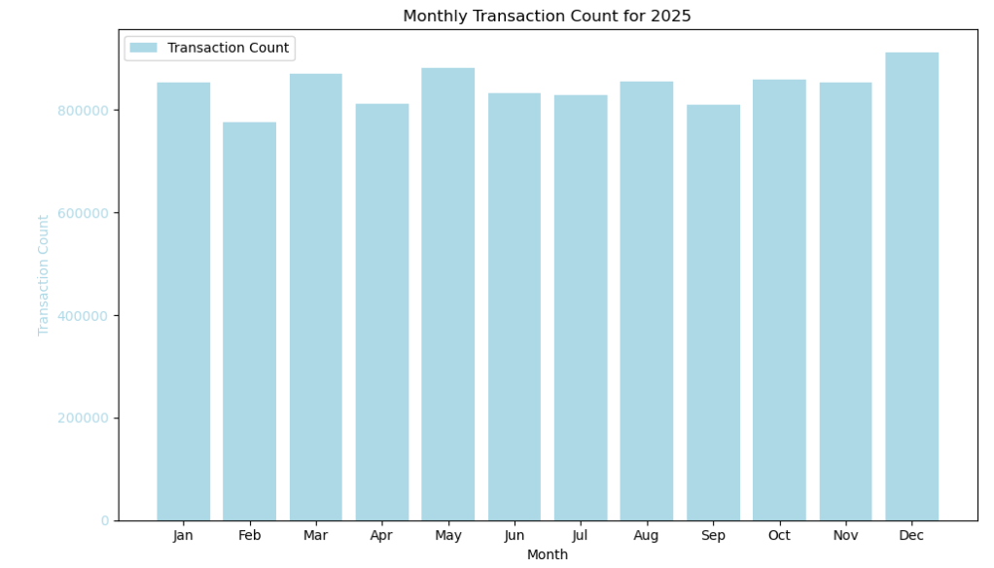

Visualize the frequency of transactions per month and then find that they are similar.

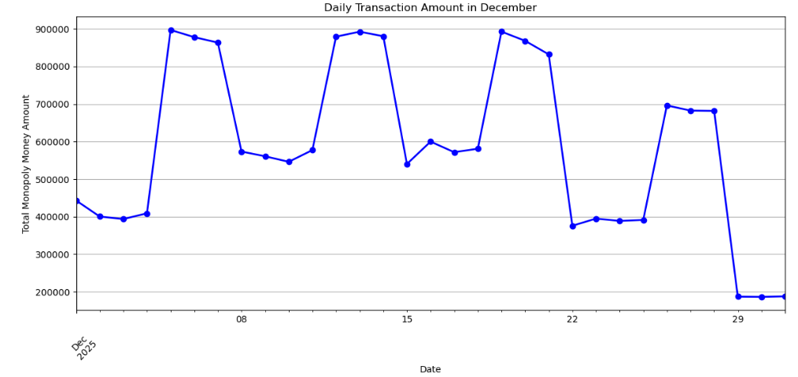

By visualizing the amount of transactions per day for the month of December (adjustable), a cyclical variation was found. The peaks occur on the three days of Friday, Saturday and Sunday.

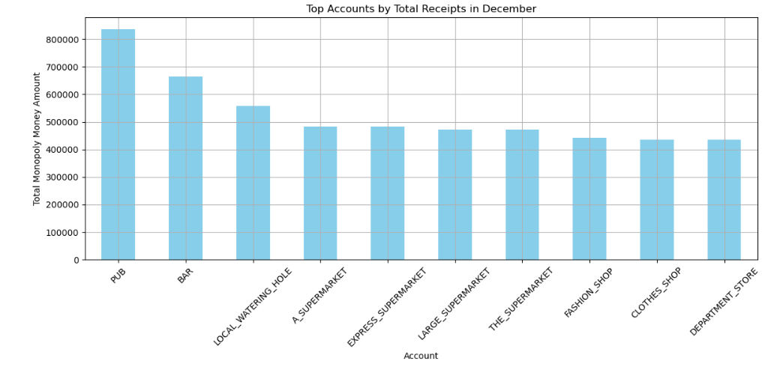

These are the top 10 merchants for December transactions.

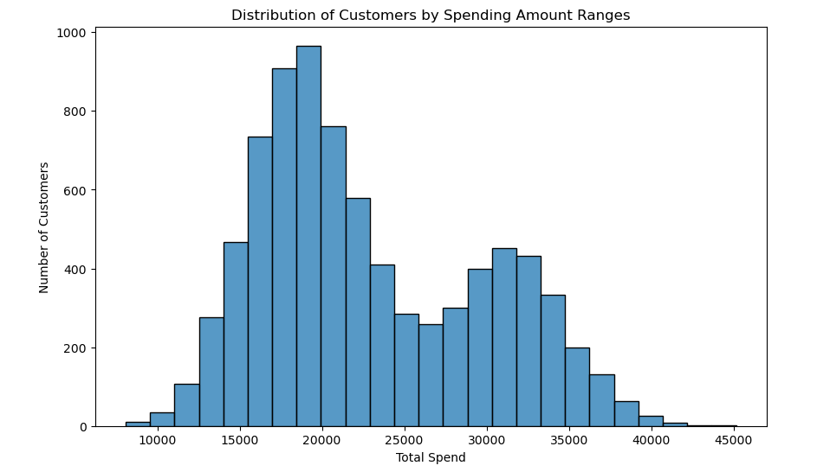

Visualize distribution of customers by spending amount ranges. Total spend in the 20,000-30,000 range was found to be interesting.

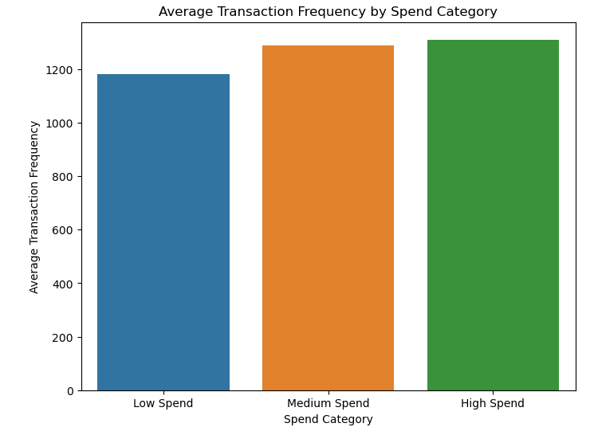

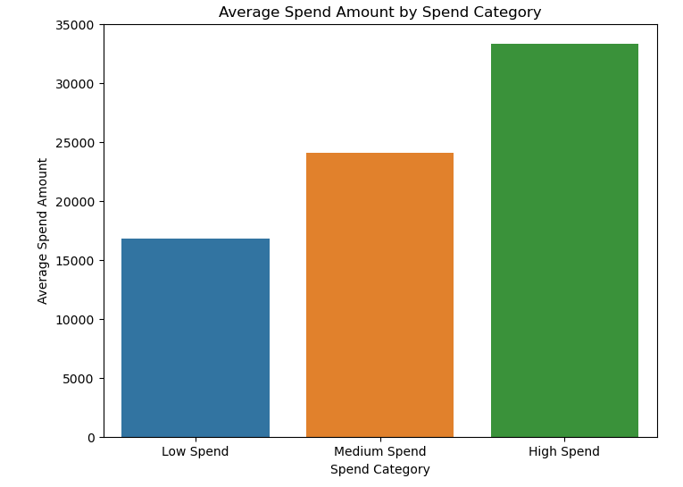

Customers are categorized into low-spending, medium-spending and high-spending groups according to their total spending. Visualize their frequency of spend and average amount of spend.

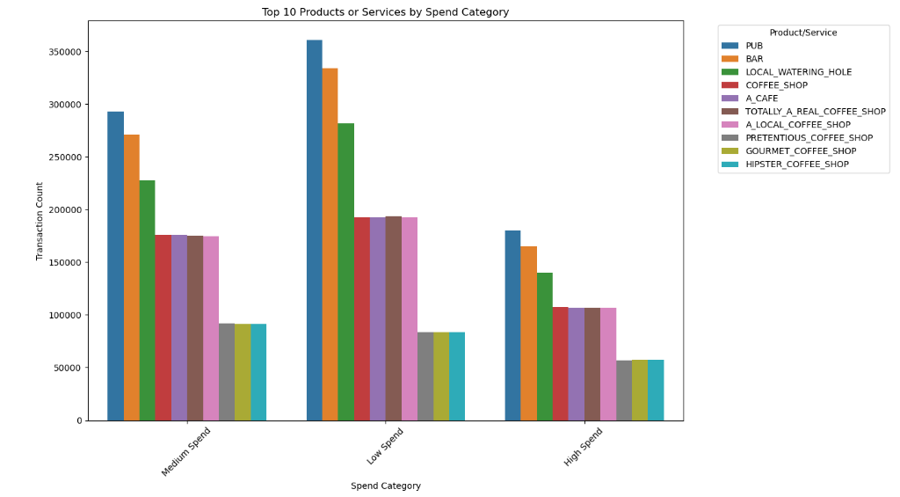

These are the top 10 best-selling products or services in each category

* Identify the outliers/abnormalities in the data (e.g. a customer has never purchased anything from a specific business and then suddenly spends well above the average in comparison to other customers expenditure at this business).

Use the IQR method to identify and flag each customer's first purchase at each merchant for unusually high spending.

